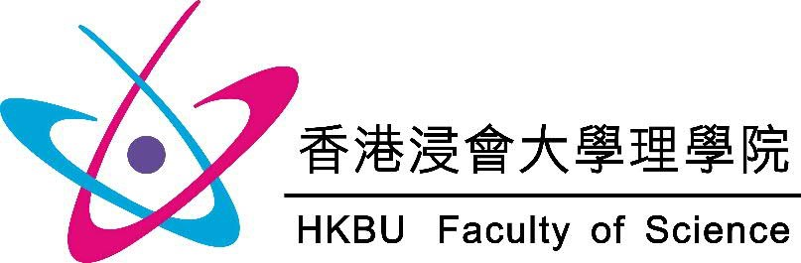
Registration Deadline
8 May 2026 (Friday)

Science Festival 2026

Registration Form

To: Faculty of Science, Hong Kong Baptist University (Attn.: Ms Lam)
Enquiry: 3411 2378 E-mail: sci@hkbu.edu.hk

- School Information*
Name of School: (CHI)
(ENG)
Contact Person: ______________________________________ | Contact No.: ___________________________________
E-mail: _______________________________________________________________________________________________

- Number of Participants
Form | F.1 | F.2 | F.3 | F.4 | F.5 | F.6 | Total
Students

Total Number of Teachers:

- Preferences of Activities
Please indicate your top 5 activity preferences (ranked 1-5, with 1 being the most preferred) and the number of participants. Activities and timeslots with limited quotas will be assigned by the Faculty of Science on a first-come, first-served basis.

Available Timeslots | Activities | Quota Per Session | Preference | No. of participants
Sustainable SciTech Workshop
09:30 – 10:30  10:45 – 11:45  12:00 – 13:00 | The Secret Skin of a Flower: A Peek into the Plant Cuticle  花瓣的秘密皮膚：探索植物角質層 | 30
09:30 – 10:30  10:45 – 11:45  12:00 – 13:00 | Synthesis of Bioplastics from Food Waste  利用廚餘合成生物塑料 | 30
09:30 – 10:30  10:45 – 11:45  12:00 – 13:00 | EcoChat: Build an AI Guide for Greener Choices  綠識聊：AI環保生活助手 | 50
09:30 – 10:30  10:45 – 11:45  12:00 – 13:00 | The Green Route: Optimising the Path to a Sustainable Future  綠色軌跡：最短路徑與可持續未來 | 30
09:30 – 10:30  10:45 – 11:45  12:00 – 13:00 | Harnessing Kinetic Energy: The Science of Electric Vehicle Regenerative Braking Systems  化動能為電能：解密再生制動系統 | 30
Scientific Demonstration & Guided Tour
09:00 - 09:30  09:30 - 10:00  10:00 - 10:30  10:30 - 11:00  11:00 - 11:30  11:30 - 12:00  12:00 - 12:30  12:30 - 13:00 | Conserving Marine Biodiversity: Insights from Deep-sea Excursions  保護海洋生物多樣性﹕深海考察的啟示 | 10
09:00 – 10:00  10:30 – 11:30  12:00 – 13:00 | Chemistry Laboratory Tour  參觀化學實驗室 | 30
09:00 – 10:00  10:30 – 11:30  12:00 – 13:00 | Plastics Come Alive  塑膠重生 | 30
09:00 – 10:00  10:30 – 11:30  12:00 – 13:00 | Semiconductor & Optoelectronics Lab Exploration  半導體與光電技術實驗室探索 | 24
09:00 – 14:30 | The Recycling Run: The One-Way Challenge  一筆畫出綠色未來：回收路線大挑戰 | Walk-ins welcome
09:30 – 14:30 | Computer Science Final Year Projects & AI Innovation Expo  計算機科學畢業專題與AI創新展

- Arrival and Departure Time

Please provide the earliest arrival and latest departure times of your school to facilitate our arrangements.
Earliest Arrival Time (e.g. 09:00): | Latest Departure Time (e.g. 13:00):

Important Note

Hong Kong Baptist University (the “University”) is committed to ensuring that your personal data is handled in accordance with the law and the University’s Privacy Policy Statement and Personal Information Collection Statement (“PPS & PICS”) (https://bupdpo.hkbu.edu.hk/policies-and-procedures/pps-pics/). Provision of the personal data marked with asterisks (*) is mandatory. In the absence of such data, the University will be unable to process registrations.

By submitting this form, it is acknowledged that the PPS & PICS has been provided and its content have read and accepted the contents thereof. For access to and correction of personal data submitted, please email to sci@hkbu.edu.hk.

The Faculty of Science at Hong Kong Baptist University has the right to record, film, photograph, or capture your likeness in any media. This media may be used without compensation or prior notification.

